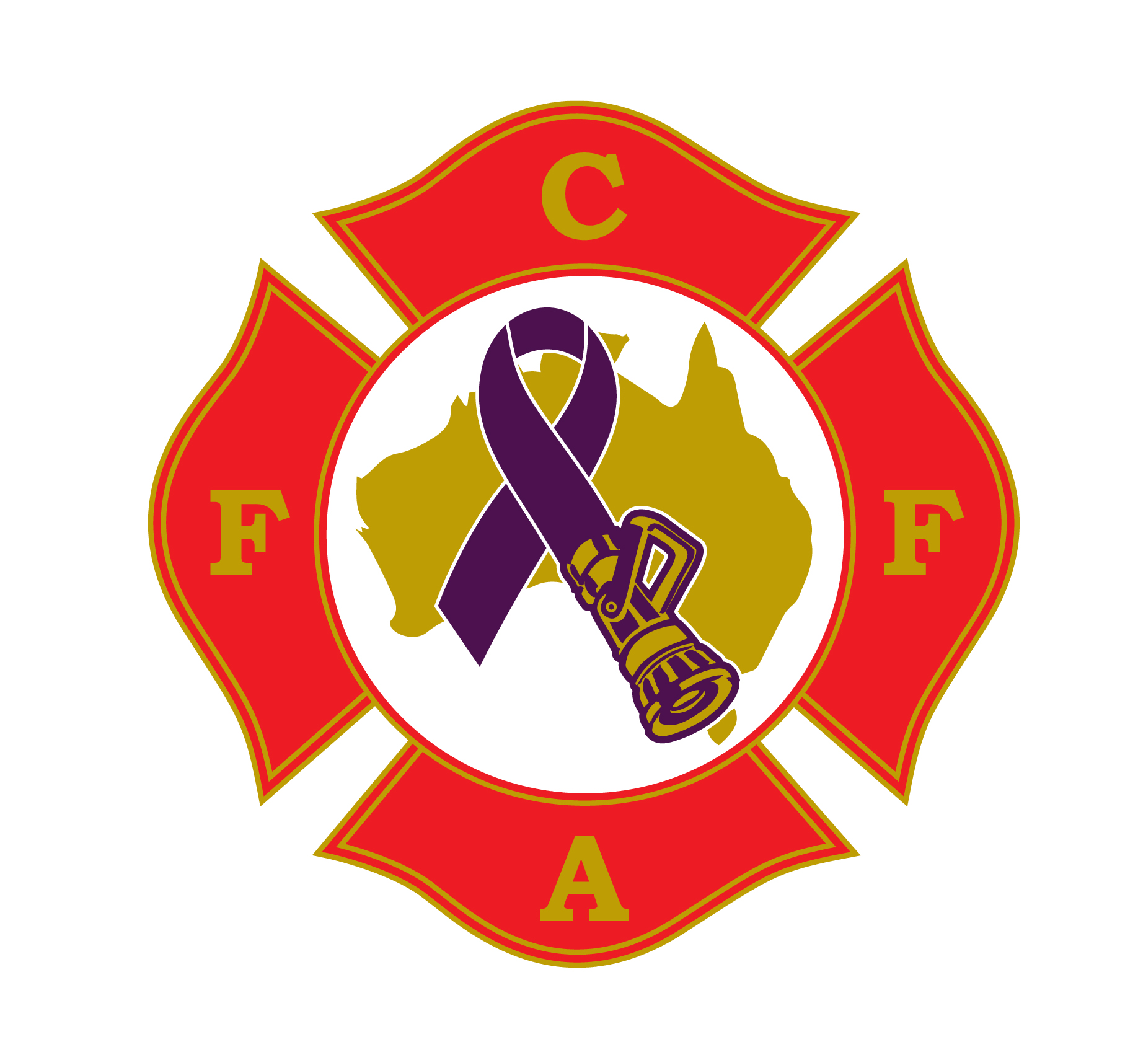

Dear Doctor,

By way of introduction, the Firefighter Cancer Foundation of Australia (FCFA) are a not-for-profit charity, providing help and information to firefighters throughout Australia in relation to occupational cancer and prevention strategies within the workplace.

|  |  |  |
| --- | --- | --- |
|  | Disease | Qualifying Period |
| 1 | Primary site brain cancer | 5 years |
| 2 | Primary site bladder cancer | 15 years |
| 3 | Primary site kidney cancer | 15 years |
| 4 | Primary site non-Hodgkins lymphoma | 15 years |
| 5 | Primary site leukaemia | 5 years |
| 6 | Primary site breast cancer | 10 years |
| 7 | Primary site testicular cancer | 10 years |
| 8 | Multiple myeloma | 15 years |
| 9 | Primary site prostate cancer | 15 years |
| 10 | Primary site ureter cancer | 15 years |
| 11 | Primary site colorectal cancer | 15 years |
| 12 | Primary site oesophageal cancer | 15 years |
| 13 | Asbestos related disease | 15 years |
| 14 | Malignant mesothelioma | 15 years |
| 15 | Primary site cervical cancer | 10 years |
| 16 | Primary site liver cancer | 15 years |
| 17 | Primary site lung cancer | 15 years |
| 18 | Primary site ovarian cancer | 10 years |
| 19 | Primary site pancreatic cancer | 10 years |
| 20 | Primary site penile cancer | 15 years |
| 21 | Primary site skin cancer | 15 years |
| 22 | Primary site thyroid cancer | 10 years |

The purpose of this letter is to provide you with some information about the significantly increased risk of firefighters being diagnosed with certain cancers. The aim is that the better informed the firefighter and their medical treatment providers are about this increased risk, the better chance firefighters have of being diagnosed early.

The patient you are treating today is a firefighter and they have requested that certain information be brought to your attention.

Worldwide research has proven that firefighters, due to their exposure to known carcinogens over prolonged periods of time, are more susceptible to certain types of cancer. Governments in Australia have recognised this increased risk and each Australian State or Territory have adjusted their workers compensation schemes to provide cover for these known occupational cancers for firefighters.

In Queensland the government have passed amendments to the *Workers’ Compensation and Rehabilitation Act 2003, with the Workers' Compensation and Rehabilitation and Other Legislation Amendment Bill 2015. Which identifies the following cancers and qualifying periods attributed to each cancer.*

As you know, early detection is the key to combating this disease. With that in mind, we ask that you discuss with your patient the full ambit of testing that can be done for each of these cancers and test regularly for all of them, irrespective of the usual general population risks and symptoms.

We thank you for taking the time to read this letter and for providing excellent care to our firefighting community.

Regards.

Bruce S Beasley

National Director / Chair FCFA Ltd. (Formally The Firefighters Cancer foundation Australia).

[www.fcfa.org.au](http://www.fcfa.org.au/)

<https://www.workcover.wa.gov.au/wp-content/uploads/2014/09/2016-Amendment-Act.pdf>