Dear Doctor,

By way of introduction, the Firefighter Cancer Foundation of Australia (FCFA) are a not-for-profit charity, providing help and information to firefighters throughout Australia in relation to occupational cancer and prevention strategies within the workplace.

The purpose of this letter is to provide you with some information about the significantly increased risk of firefighters being diagnosed with certain cancers. The aim is that the better informed the firefighter and their medical treatment providers are about this increased risk, the better chance firefighters have of being diagnosed early. The patient you are treating today is a firefighter and they have requested that certain information be brought to your attention.

Worldwide research has proven that firefighters, due to their exposure to known carcinogens over prolonged periods of time, are more susceptible to certain types of cancer. Governments in Australia have recognised this increased risk and each Australian State or Territory have adjusted their workers compensation schemes to provide cover for these known occupational cancers for firefighters.

In Victoria the government have introduced the The Firefighters' Presumptive Rights Compensation and Fire Services Legislation Amendment (Reform) Act 2019.

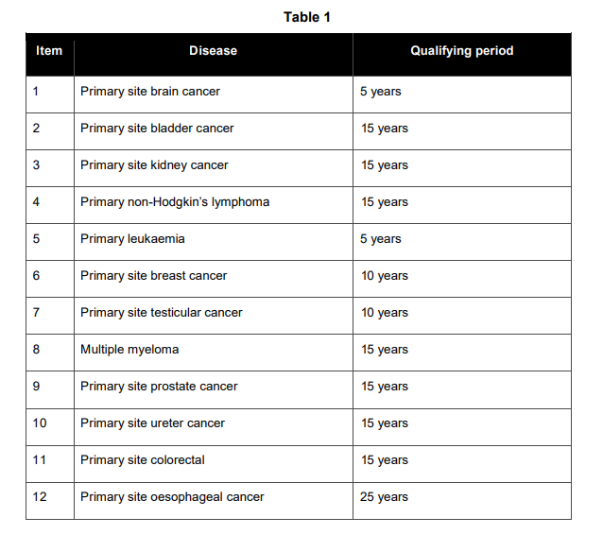
As you know, early detection is the key to combating this disease. With that in mind, we ask that you discuss with your patient the full ambit of testing that can be done for each of these cancers and test regularly for all of them, irrespective of the usual general population risks and symptoms. We also advise that even though not on the above list, we are seeing an increase in pancreatic cancer in firefighters throughout the country.

We thank you for taking the time to read this letter and for providing excellent care to our firefighting community.

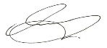
Regards.

Bruce S Beasley
National Director / Chair FCFA Ltd. (Firefighters Cancer foundation Australia).
www.fcfa.org.au
https://content.legislation.vic.gov.au/sites/default/files/0144a0e3-8e06-3542-8015-d5da0191c4b8_19-20aa001%20authorised.pdf

